**BREAKING GAME NEWS**

Peter in the hit game Fortnite?

Shocks all fans of both Fortnite and family guy.

Peter is a cool guy from the hit show family guy but now is inside of the game Fortnite for a collaboration.

**Dave the diver released**

A new game called “Dave the diver” has been released, Dave the diver is a game about the ocean where a man called Dave goes to get fish for a sushi restaurant owned by a man called cobra, in the ocean there are many dangers to discover with a big story line. tons of jokes to make your experience enjoyable and overall, a great game.

**ROBLOX THE HUNT ENDED**

Roblox the hunt ended; you can no longer get all the cool accessories. The hunt event was a event from Roblox making 100 games have their own special addition for the hunt. If you did 95 of the games, you would get every accessory which was a hard feat to achieve in the event, it ended 3/30/2024.

Jackson Meckstroth

Siblings

Elissa-Moreno-Rosquero

Do you have siblings? Because I do! Even though they are the most annoying little things, I still like them. I have two older sisters and one little sister that adds up to 4. Let’s start with my older sister. Her name is Jacqueline, her nickname is Jackie. She is 16 years’ old, she hates school, but she is smart. My sister is also mean but kind as well. That’s all about her. Next is my other older sister. Her name is Kimberley her nickname is Kim. She’s always on her phone she is also very smart, she in gifted program. She loves spicy chips and sodas. She’s very kind and funny. The last of all is my little sister. Her name is Roselyn and she is 8-year-old. She’s mean but nice, and she’s also a crybaby, but very kind crybaby. She hates spicy stuff she spites them out. And that’s all of my 4 siblings. I hope you love my story from Elissa-Moreno-Rosquero.

About me

Hi my name is Axel and my favorite color is blue. I love football/soccer I’m going to tell you to be the best I your team like Messi, Neymar, CR7 and Vinicius Jr. First you do is practice your dribbling cone drills and do some shooting drills. Passing drill do like every weekend. Then go to practice with teammates. Eat healthy like vegetables and fruit water. Also work out at the gym for about 30 minutes. And repeat it over and over again and you will be the best.

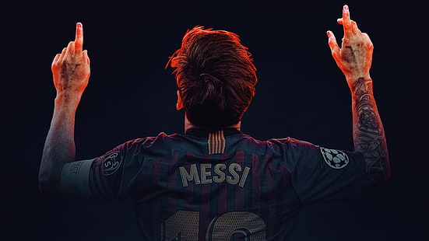

|Stuff about me|

My name is Marcelo I am a boy. I have good grades and I am

I have long brown-ish hair and I In gifted in school and go to

Have brown eyes. Eisenhower Elementary School.

I have a mom, dad, 2 brothers one I am very good with technology

Named “Antonio” and one named I can code stuff and do a lot of

“Luis” and a cat named Beau. Other stuff with technology.

I can write essays very fluently and I do stuff when asked and can

I can analyze a text/source with ease Do a lot of stuff some people

And can tell the difference between Can’t do, and help people if asked

A primary and secondary source. For help.

I was born on August 18 2013 I am 10 I am skilled at a lot of things

Years old I am almost 11 years old. And I can do stuff.

Marcelo Parrado

Football is the Best!

Getting the ball, getting tackled, getting hurt, football is an outdoor game played by two teams. Having eleven players in each team builds team spirit. In my opinion football is the best thing in the world because you can tackle people and run the ball. Me personally I love scoring touchdown.

Shona’sti Holte

All about me

Hello, my name is Angelina, and I’m going to tell you all about me. I like to go shopping with my parents and go out to eat. I like Chick-fil-a and PDQ and McDonalds. I like to hit my brother while he is sleeping and steal his snacks when he is not looking. My favorite color is purple and blue. I have brown hair and brown eyes and I am Hispanic. I am from Honduras. My mom is from Honduras and my dad is from Nicaragua. I like to go on TikTok and YouTube and go for walks in the park. My Birthday is July 30th and I was born in 2013, I’m 10 years old now. I like fries with chicken tenders and a vanilla milkshake. I have 1 great sister and 1 bad brother. My parents spoil me a lot. I like reading that’s my favorite subject, and sometimes I like going to school because I get to see my friends. I could be hungry sometimes when someone shows off their food to me. This is all about me.

Angelina Espinoza

All about me

My name is Miguelangel. My favorite video game is Fortnite, I like to play Fortnite and play soccer outside in my spend time, I’m 10 years old, I like to play Baseball and soccer, I like science, math, art and P.E, I’m , I was born in Venezuela,  started to play Baseball when is was 4 years old and I started to play soccer when is was 5-6 years old.

Miguelangel Pirela Salcedo

Fortnite

How to get good at Fortnite play with steven or Xavi h because him and I are the best Fortnite players in this school and one day we will win FNCS! Steven and I already tried to win duos cash cup! It did not go as we thought it will. So we will keep trying over and over until one day we win FNSC and will be called the kings of Fortnite. But Steven and I constantly dream that one day we will win it so every time we go on Fortnite we try hard and harder till that day comes and we win.

Xavier Hernandez

All about me

Hi my name Steven I am going to tell you all about me. I was born on February 12, 2012 and am 12. I like playing Fortnite and hope to win FNCS with my friend Xaiver. I like eating Egyptian food and I am from Egypt. My favorite colors are red and purple. My school is called Eisenhower Elementary I am in fifth grade. When I am at home, I like to play Fortnite with Xaiver and play cash cups with him and I hope to make my first earnings with him.

Steven Elksan Alfy Fekry

My Favorite Football Player

I like Justin Jefferson because he is one of the best receiver in the NFL

right now and he plays for one of my favorite teams. And he makes awesome catches.

Charles Showers

All about my sisters

Kate Maily Tepetate

“GET OUT OF MY ROOM!” Having little sisters is so annoying and guess what I have – two little sisters and they are trouble! They also get everything they want but they get in trouble almost all the time: get in my sisters, always come into my room and it’s so annoying. They are always hitting one another and sometimes I will get in trouble because of them. Sometimes I have to take care of them and occasionally, let’s just say there is a lot of fighting going on between them, I have to break them apart. They are always losing their toys and they refuse to go to sleep early and sometimes I get to school late because of them. They can also be funny cute and nice to me. Whenever they come to my room they go through and take my stuff out of my room and bring them to the living room and that is one example of how they get me in trouble. But whatever they do, I still love them so much. So do you want a sister, yes or no?

Kate Maily Tepetate

All about my dogs

My dogs names are Leila and Scatty, and they are trouble! They are cute and mine forever. I take them for walks and I play with them. Scatty is a Frenchie and Leila is a pocketpit. Scatty is 2 months old and Leila is 3 years old. I love them very much and love spending time with them. They always make my days more fun!

Zuri Bochantin

All about how I love my baby brother

          By Kaylee Poot Alonzo

Did you just spit on me?!? Having a brother is kind of hard then you think, especially if he’s one month old. I am so glad I don’t have to change his diaper and all I get to do is take care of him and feed him his bottle and my mom does the rest. Sometimes when I’m on the phone with my friend while playing Roblox I let him play. Because what if he wants to play right? He is so adorable he looks like a little potato and his cheeks are chubby like a chipmunk and its like he has food saved for later in his cheeks. He also cry’s a lot but its okay because I love him. He was born on February 22 at 9:02 pm, and my brother and my mom are my whole world. He is charming and when he sleeps he cant sleep without my mom because now he got used to it.  Another thing is that he also smiles in his sleep and he looks so cute and what makes it cuter is because he has dimples but only on one side. When he eats he makes a big mess all over his face, and he moves around like a worm.

Kaylee Poot Alonzo

The games I like to play

Playing with my friends is fun. We play Roblox. And there are fighting games, building games and racing games. I like fighting games most. You have an avatar and sometimes a character help you win. In fighting games sometimes you have weapons. Fighting games have different modes but you have to activate them. I like play Roblox with my friends.

Alexander Ocampo-Sauz

My Favorite game

My favorite game is Mario kart 8 because you must race in cups to win First place plus there is a lot of characters in the game and you have to unlock karts and the wheels. And you can do time trials and more characters in the game. There are a lot more fun gadgets in this game. That is why I love to play it.

Alejandro Gonzales-Sauz

**All about** 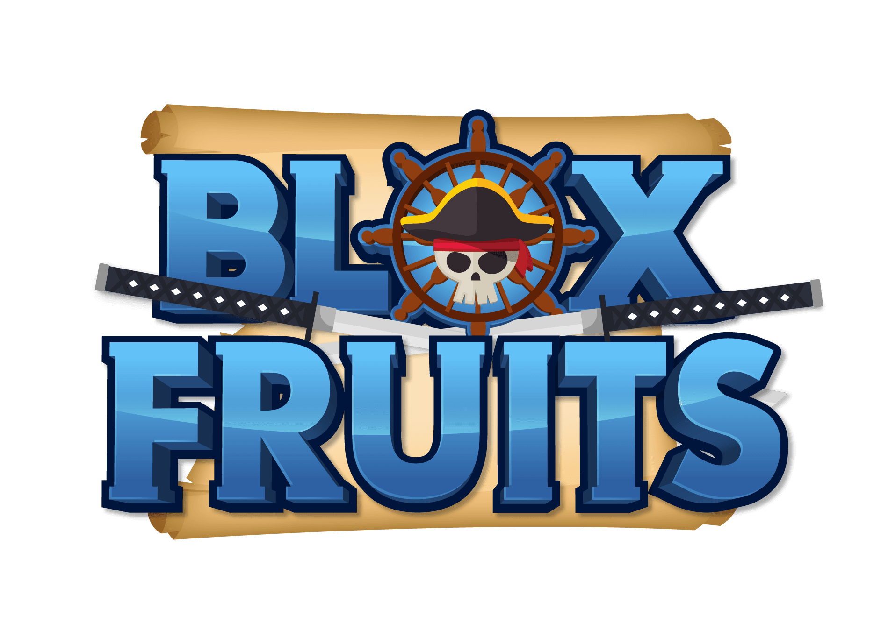

**In the month of January 2019, a game was born. Rip_Indra and Mygame47 are the creators of the game “Blox Piece”, which was the game’s name at the time. 5 years later, it now owns over 20 billion visits with a 94% likes from all in this community. But what makes it this amazing? 1 thing the creators have done is unlike other games that make random updates, Blox Fruits adds what the community wants using polls and votes. Also, they pour their hearts into their updates to make it perfect. Examples are the 2nd and 3rd sea and adding fruits with amazing moves and animation. But soon, Blox piece had to change their name to avoid copyright. So, they changed** **their name to Blox Fruits since their game was based mostly on fruits. Even though updates are slow, when they come out, it always adds something new, and with an update that will change the whole map, the future of the game is bright with amazing updates, stellar gameplay and out of the world animation. Talking about gameplay, let us talk about it. As everyone knows, a good game needs good gameplay, and Blox Fruits gameplay is outstanding. The 1 thing that makes Blox fruits game special is that there is no end goal. There is no final goal or boss to defeat, and there is always something to do. There are many things to do, like obtaining titles, defeating horrific beasts, or getting godlike weapons, there will always be an adventure waiting to be completed, and with every new update will also come with a new adventure. No matter how many items you obtain, a new adventure awaits.**

**Jairo Mendoza Tepetate**

Different types of Sharks

There are many different types of sharks, but they also have many facts about them. I’m going to talk about 6 types of sharks with fact about sharks. The first shark I’m going to talk about is my favorite shark the hammerhead shark during the day hammerhead sharks sticks close to shore and hunt offshore at night despite their large heads they have a small mouth they feed on mackerel, herring, sardines, and other fish. They usually live in warm tropical climates like south Africa, Red Sea, Indian ocean, Japan, Hawaii, Tahiti, Australia. Male hammerhead sharks can grow to be 12 feet in length and weight 500lbs on average. Now we are going to talk about the mako shark lets stark with mako sharks are one of the smartest sharks in the ocean. Mako sharks are the fastest sharks in the whole entire world that mean they can outrun many sharks. Another fact about mako sharks is that they are one of most aggressive shark hunters. Mako sharks can only keep moving to live. Another important fact is that mako sharks prefer warm water. Mako sharks can also see in the dark. The last fact is that female mako sharks don’t reproduce very often. Now we are going to talk about bull sharks. bull sharks are large stout predators found in tropical and subtropical waters around the world. Bull sharks are considered a constant threat to humans with more than 100 historical attacks. Bull sharks manly eat bony fish and small sharks they also eat birds, dolphins, terrestrial mammals, and turtles. Now we are going to talk about the lemon sharks. Did you know lemon sharks are named for their brownish yellowish skin. Lemon sharks are the medium size sharks. Lemon sharks are commonly found in shallow coastal waters. Lemon sharks have a unique ability to tolerate low salinity levels. Lemon shark are the most excellent swimmers. Lemon shark are very social sharks. Now the whale sharks. Did you know whale sharks are filter feeders. Another whale fact is that they are ovoviviparous. They are also cartilaginous – their skeleton is made of cartilage not bones. The last fact is that whale sharks live longer than most other sharks. The last shark is the tiger shark. The tiger shark Is one of the three species known as man eaters. Tiger sharks inhabits different kinds of marine habits. Tiger sharks’ dark stripes fades as the sharks matures. Tiger sharks skin feels like sandpaper. Tiger sharks’ body does not have a backbone. Tiger sharks are the only kind species with suctions holes.

Jada Jackson

All about my free time

Hello, my name is Ayanna. Today I’m going to tell you about how I like to spend my free time. I like to play outside in with friends like Mia. I like to play at the park I like to run around in my apartments I like to play in my house I do Tik Tok sometimes.

First in Foremost, when I’m on my free time like when I’m home I be on my phone for like 15 minutes to 30 minutes because I get bored easily so to make myself not bored I just go outside in I try to fall asleep but it hard so I try to watch tv but then I go outside in go to my friends house in ask there mom can they come out in if they say yes we either do cheer or dance battle because it barley be people outside so we make fun other my reason 1 is when we play we also go to store like Publix dollar tree we ride the bikes around through the apartment we go to long park we come back at night time it was one day we came back at night time after we left Publix we was running late at home we had to go through a trail were coyotes lived we were scared.

Likewise, we were scared. Then we arrived home 20 minutes later in we had to come in at 6:45 now we come in at 8:00 we had fun, but it was scary in fun they were even crying I couldn’t see I almost ran into the wood because I can' t see at night time. My reason 2 is we go to dollar tree we have some much fun I just love going to have a good day.

The end, hope you had a good day reading all about my free time.

A’yanna Morrison

One Piece by Kai

One piece is a anime/ tv show with the main characters being Luffy, Zoro, Nami, brook, Franky, Jimbei, Robin, Chopper, Ussop, Sanji being the main character's and they are all on the same team the team is called the straw hat pirates and they all had their own goal and wanted to become king of the pirate he wanted to be king of the pirates because he was inspired by his idol shanks of the red hair pirates he was one of the strongest pirates he could even compete with whitebeard the strongest pirate in the entire world then he was killed by his own crewmate now the strongest pirate is shanks. Luffy traveled through many islands and villages his final enemy was a man named Kaido. Kaido killed Luffy then a mysterious god called joy boy brought Luffy back to life and possessed his body then Luffy punched Kaido so hard he died by rushing into the core of earth and was burned by lava. Then his teammate big mom was killed by Trafalgar d water law of the ope-ope fruit. This is a devil fruit devil fruits grant the users special ability's but takes away swimming. A group of cartoon characters
If you do not watch one piece, you don’t even know what you are missing

Malakai Evans

AH-64E crashes at JBLM

A U.S. Army AH-64E Apache attack helicopter assigned to 4-6 Assault Cavalry Squadron (ACS), 16th Combat Aviation Brigade, sustained a crash landing at the property of Joint Base Lewis-McChord (JBLM) in Washington State on Mar. 27. The incident occurred around 9:30 p.m. during a routine training exercise.

Both pilots survived the crash and were then transported to hospital. They are in good condition now.

Military officials from Alabama are doing investigation to establish why did this happen.

Residents near the crash site reported hearing weird rotor sounds from the helicopter before the incident. Monique Anderson, who lives about a mile from the crash site, said she is used to helicopters flying overhead on training missions, but last night, she and her husband heard something different. The site will likely be blocked for several more hours while the investigation continues.

Nearby Sheriff's Office and firefighters and crews from military base all responded to the incident.”

Mathieu Tran

All about Fortnight by Dorian

Fortnight is a game that you can play with your friends or anyone else then you join a game then you get put in a bus then you land where you want you find guns and the guns are a common uncommon, rare epic legendry and Mythic and exotic. Then if you find someone you have to battle them then you build and if you get low you must find big pot or a med kit. That is to help you to get your health back you start at 100 health but if you use 2 big pot you will get 100 shield so then if you get full health you will have 200 so 100 heath and 100 shield so if you see someone you have to build so your health does not get taken if you get attacked at then you fight back. Ther is a lot of other Healths to use when you are low like flow berry fizz flopper shield fish slurp fish those help you get your health and your shield back then there is a thing called a bunker it gives you better loot if you win against a boss, it will give you a medallion which gives you heath and his gadgets and there is 100 people in the match. And there are 12 different zones after like 3 or 4 zones it will take 2 damage then 5 then 10 and you must be the last person standing to win and to find good loot is from a supply drop and you can do a bounty target and if you win against the bounty, you get 100 gold the gold is you can by stuff Frome a vending machine. And that all about Fortnight.

Dorian Selmani

All about Dragon ball Z

Dragon ball Z is a Japanese anime television series produced by Toei Animation. Part of the Dragon ball media franchise, it is the sequel to the 1986 Dragon ball television series and adapts the latter 325 chapters of the original Dragon ball manga series created by Akira Toriyama. Due to the success of the series in the United States the manga chapters. Making up its story was initially released by Viz Media under the Dragon ball Z title. But there was a big tragedy with Akira Toriyama. On March 1, 2024, he passed away due to a blood clot. If you do not know what a blood clot it is a semi-solid or gel-like masses that form in your arteries and veins. Also, they can cause serious medical issues, including deep vein thrombosis and heart attacks. Anyway, Dragon Ball Z is interesting anime series that I enjoy watching. I believe that this is the best one out of all these series.

Tremaine Skinner

All about my dog Kodi

By: Leila.t

Kodi is a French bulldog and has a Brendel coat and is super crazy but is a loving dog. He likes dog bones and the color orange. He LOVES people and is never aggressive to dogs OR people. FUN FACT Kodi loves to dig into random things. He is a certified service dog. He loves sitting next to people and does NOT like baths at ALL! He gets hyper easily and loves racing. This was all about Kodi so now you know more about him!!

Leila Theofilou

The Best Teacher Duo Ever

The best teachers Mrs. R and Ms. Wallingford the best duo because the best teacher does the best party and make learning fun like the fun learning unexpected fun in math and reading and they the like to make jokes and the books are funny and fun like “Storm Runners” and it can be scary and sad like the book “Terrible Things”. Math is cool and Ms. Wallingford makes the math fun, and she goes over the math we do not know in math.

The best teachers.

By Brayden Armstrong

All About

ROBLOX is a mobile game more with games created by people all over the world. If you download ROBLOX you will have to say birthday date. Then you can give your charterer then write a password you will remember. Then say what gender you are and welcome to ROBLOX. You will first see that there are many games to play from. You can also customize your charterers.A group of toy figures

In ROBLOX there are many popular games like BLOX FRUTS, BROOKHEAVEN, Adopt Me etc. Creators of games will sometimes update their games with new features, fix bugs etc. Even the ROBLOX team will update their game for example THE HUNT from 3-15-24 to 3-29-24. Fun Fact: Did you know that on 9-1-06 was the day ROBLOX came to the app store and the first game on ROBLOX was a game called Rocket Arena?

Alan Cruz

Puppy Crime

By: Skye Smith

IT ALL STARTS NOW

CUPCAKE Once was a sweet little pup until it all changed after a little baby pup named Paris arrived Cup didn’t like that all the attention was going to Paris so she... wet everywhere and Paris got blame for wetting on the couch the carpet the floor on the bed. Paris wasn’t usually this bad until it all went wrong Paris started chewing up stuffed animals, pillows, stealing socks going through the trash at night doing her business in shoes etc. After Cupcake realized that Paris was getting in trouble, she thought she was going to get all the attention. But since Paris was being so bad the attention was still on Paris cupcake got tired of it and tricked Paris into locking her outside in the rain Cupcake got in A LOT of trouble, she did get the attention she wanted. Then it all changed…

All about my dog Miche

By: Malayah Pennington

Miche is a French bulldog with a brindle coat super hyper but is a happy and kind dog. He only gets mad at people when they blow in his face. Some fun fact about him is that he loves to dig up stuff. And loves to lay by people’s side. He loves people and kids and loves to eat! A LOT! And loves to play with big dogs even know his a small dog he will only play with the small dogs if he is getting tired. It takes a lot of passion to tack care of him. He is a fast runner and loves to sit next to the window. That is all about my dog Miche ...

ALL ABOUT MEXICO

Mexico is full of beautiful flowers and culture and animals and a lot of opportunities but one of the best things about Mexico is the music they have artist like Selena Quintiliani Perza chileno Sánchez and peso Pluma nata cannolo Xavi and much more these people are good artis in the music industry these people are loved by many people and also people are in coughed to make music because of these people they give them hope and joy. Another thing that gives people hope is the food they can open a restaurant or make food, start a food chain, and become a successful cook and restaurant owner and if you do not want to do any of that you can be floweriest there is a lot of beautiful flowers you can get from outside and make flower bouquets to make money because the flowers in Mexico flowers is very beautiful one more thing more beautiful is the culture they have a day of the dead to honor the one who passed and to help them pass to the real world by putting the picture on their ofrenda they also have mariachi bands that sing song that are very meaning full to the people it brings them joy to listens to their music another thing Mexico is known for is there horses they have all different horses over their they have horses races that people bet on to make money or lose but it is always fun to watch their horse races.

Jesus Jimenez Vega

ALL ABOUT the series ONE PIECE

One piece is an anime series with 1100 episodes currently the one piece was started by Oda the creator of one piece the main character of one piece is monkey d Luffy his crew name is the straw hat pirates.

The straw hat crew has 10 crew members. Luffy, Zoro, Brook, Nami, Chopper, Sanji, Franky, Usoap, robin and Jimbei. those are all the crew members.

One piece also has many different fruits that you can eat they will give you powers there are many types such as a logia which would make you immune to attacks and a logia is an elemental type fruit.

One piece also has many swords that they can use such as the mole and yoru (Mihawk’s sword) and Zoro’s true triple katana those are some of the many swords that characters use in one-piece.

-By Nelson Fuentes

                     All About Mexico

 First Mexico is a good place to visit. It has cool places but the best places to visit is Cancun, Mexico City, and Puebla. Those are all cool places to visit. So, I would recommend you too visit those places. Mexicans Also have a nice culture like one of the most popular celebrations that they do is the birthday of la Virgen De Guadalupe which is celebrated December 12 because it is the honor of when the Virgin Mary made her appearance to a young man in 1531. They also have a cool celebration called a Quinceanera, it is mostly for girls, but it is a celebration for girls when they turn 15 years old and go from girlhood to womanhood and it is a huge celebration the birthday girl. Another thing that is incredibly famous in Mexico is the food, many that have visited Mexico say that the food there is delicious and flavorful. Mexicans also have so nice music but one of the most famous music style is mariachi and lots of people like that style of music and you might even like it too. So, if you ever want to go on vacation, I recommend you go to Mexico.

Isabella Acuna-Rivera

All About Fortnite

Fortnite is a game that you play and when you get into a match you go you go you go you go on the battle bus you get off and glide to the spot you want to go and then you look for weapon and the weapon can be Comen uncommon, rare, epic legendary and exotic. Then if you find someone you can build or if you are in zero build then you cannot build so if you are in build then you can build, you can box them, and you can edit your wall and win but if you get low on health then you can heal with med kit, big pot or mins or bandages splashes flow Bary fizz or flow Bary or there is a flopper or shield fish slurp fish or jelly fish and Icey flopper and there different types of chest common chest and rare chest and there is god chest and there are air drop and an air drop is and cate that comes from a shadow briefings and the air drop and the shadow briefings and also can get a car and a bounty or a buried Trester.

by Noah Block

Baltimore Bridge Collapse

Singapore-based Grace Ocean Private Ltd. owns the Dali, the vessel that lost power before it slammed into the Baltimore Bridge. There were 21 sailors on the cargo ship when it crashed. Rescue teams are looking for the sailors.

There was a group of construction workers and cars on the bridge when it collapsed. The bridge crushed the cargo ship. Some people witnessed the bridge collapse onto the cargo ship. The families of the construction workers are worried about them and hope that they are okay.

Avacyn Barnes

One Piece

One piece is a Japanese manga made from the author Eiichiro Oda this action-packed manga was made in July 22 1997 lets talk about the main character made by Oda. Monkey.D.Luffy when he started his journey on the sea as a pirate he was 17 with a red buttoned tank top and blue shorts and wore a straw hat. first to prove he was worthy to his village there was this monster in the sea called a sea beast he defeated is so the village gave their goodbyes to him but in the scene where he defeats the sea beast his arm stretched and smacked the sea beast so when he was younger in his village pirates came to their village and the was called red hair shanks one of the most famous and most powerful in the sea he influenced Luffy to become a pirate. But there was thing called a devil fruit there was bunches of them and they were left by the last king the pirates but he was executed by marines ten years ago his name was Gold D. Roger red hair shanks found the king of the pirates treasure and he found the gum gum fruit also know in the anime as gomu gomu no mi its ability to make your body in to rubber and give you immense strength and insulate electricity through his body shanks brought the devil fruit with him in a chest when shanks became friends with the village luffy was very hungry so when shanks wasnt paying attention to luffy he opened the chest and ate the devil fruit without knowing that when you eat you cannot swim and become weak when are in the water when shanks heard luffy says shenks when are you going to pay attention shanks looks around to luffy and says he is busy until he sees the devil fruit in luffy’s mouth and him and his crew freak out and tell him to spit it out but its already gone not knowing luffy’s life will be changed forever from then on. That is luffy’s journey it is yet to be filled with a lot more. This is his crew when he becomes 19 after time skip.

Merek Stanley-Normand